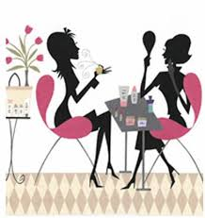
Get ready for a GREAT Virtual Experience !
Enclosed is your virtual Beauty Packet
At our Virtual event you will need :
hairband, 2 washcloths- , mirror, a bowl of water & a smiling face !!
C=Cleanser, D=Day, N=Night , E=eyecream M= Microderm, PM= pore Minimizer

Get ready for a GREAT Virtual Experience !
Enclosed is your virtual Beauty Packet
At our Virtual event you will need :
hairband, 2 washcloths- , mirror, a bowl of water & a smiling face !!
C=Cleanser, D=Day, N=Night , E=eyecream M= Microderm, PM= pore Minimizer

Get ready for a GREAT Virtual Experience !
Enclosed is your virtual Beauty Packet
At our Virtual event you will need :
hairband, 2 washcloths- , mirror, a bowl of water & a smiling face !!
C=Cleanser, D=Day, N=Night , E=eyecream M= Microderm, PM= pore Minimizer

Get ready for a GREAT Virtual Experience !
Enclosed is your virtual Beauty Packet
At our Virtual event you will need :
hairband, 2 washcloths- , mirror, a bowl of water & a smiling face !!
C=Cleanser, D=Day, N=Night , E=eyecream M= Microderm, PM= pore Minimizer

